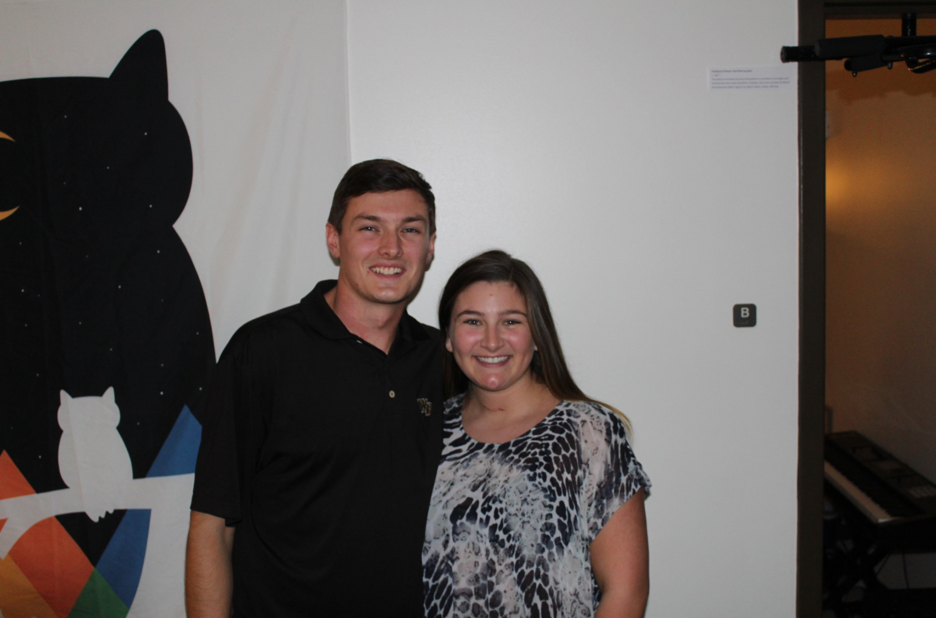

Shelby Ellis with her boyfriend, Joe Julian, the day they moved back to college — five days post-surgery— to embark on their senior year (Photo courtesy of Shelby Ellis)

**Americans cautiously optimistic about Biden’s Cancer Moonshot Initiative, but say it comes at a challenge**

***Cancer impacts nearly every American's life. Experts say the goal to cut the cancer mortality rate in half within 25 years is ambitious but possible.***

**By Lauren Berryman**

In March 2019, Shelby Ellis did not feel like herself. She felt tired, developed anxiety and gained weight despite eating well and working out more than ever.

She scheduled an appointment with her primary care doctor to test her hormone levels, although she said her doctor thought these tests were unnecessary. Her thyroid levels came back abnormal, but after a second test, the results were normal. Her doctor said nothing was wrong.

“I had to really advocate for myself in those appointments. Because deep down I knew there was something wrong,” Ellis, now 24, said in a recent interview.

After another test, ultrasound and biopsy, what Ellis thought was hypothyroidism turned out to be papillary thyroid cancer. The day after the biopsy confirmed this diagnosis, surgeons removed her thyroid in August 2019. She moved into college to start her senior year five days later.

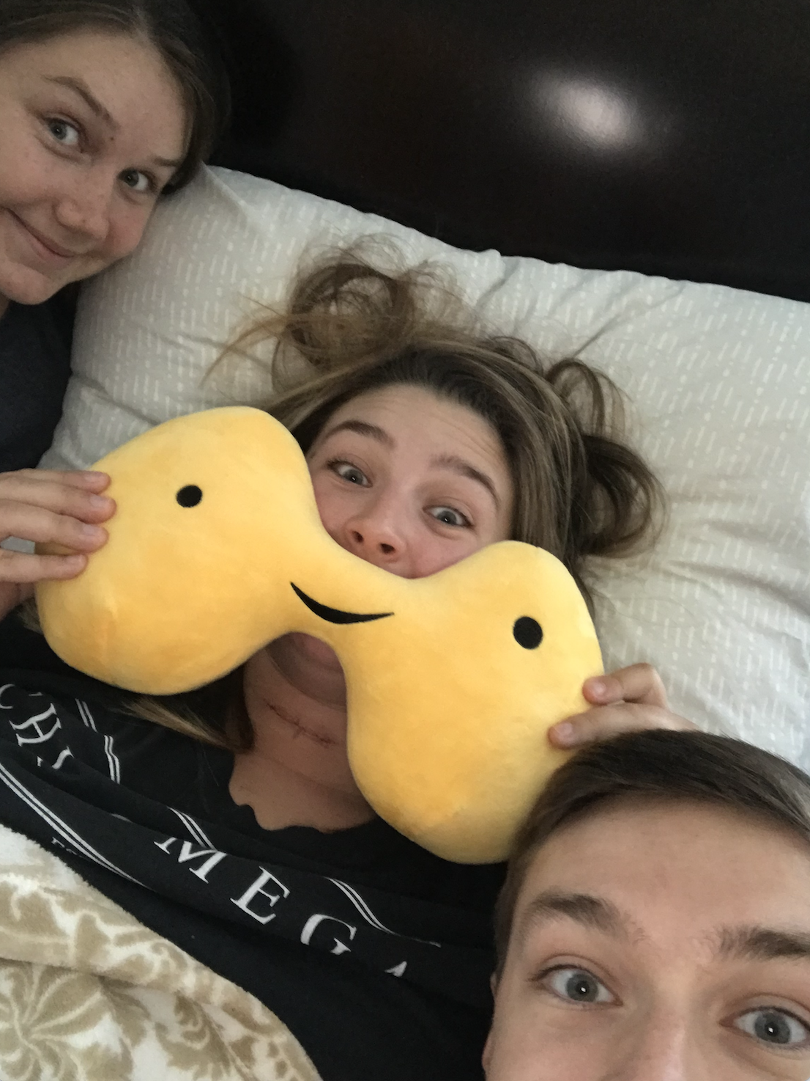

Ellis’ friends gave her a new “thyroid” post-surgery. (Photo courtesy of Shelby Ellis)

Shelley Fuld Nasso, CEO at the [National Coalition for Cancer Survivorship](https://canceradvocacy.org), has worked in cancer advocacy for more than 15 years.

“We hear from survivors all the time that the first year after treatment was harder than the treatment itself because they're left to put back the pieces of their lives,” Fuld Nasso said.

Ellis said some people would tell her thyroid cancer is the best cancer to get. While she is happy her cancer is in remission, she admits surviving cancer comes with challenges.

“People just assume that once you're cured that you're fine,” she said. “But you have all these recurring thoughts. My biggest one is I'm always afraid it's going to come back or I’m going to get it somewhere else,” like in her lymph nodes, she said.

Living with cancer and surviving cancer bring a host of challenges to patients and families. President Joe Biden relaunched the [Cancer Moonshot Initiative](https://www.whitehouse.gov/briefing-room/statements-releases/2022/02/02/fact-sheet-president-biden-reignites-cancer-moonshot-to-end-cancer-as-we-know-it/) on Feb. 2, which aims to cut the cancer mortality rate in half within 25 years and improve the quality of life for those living with and surviving cancer.

The initiative, first launched in 2016 under the Obama-Biden Administration, aims to accelerate cancer research, encourage cancer screenings, increase funding and address health inequities to decrease the number of people dying from cancer.

“Many of us were initially skeptical that it could deliver,” Dr. Peter Adamson, who was appointed to the Cancer Moonshot Blue Ribbon Panel in 2016, said. “At the time, nothing was getting through Congress, but the Vice President was rightly convinced that cancer cut across party lines.”

Doctors and researchers explain that progress made in a relatively short amount of time has already come a long way. From 1999-2018, the cancer mortality rate decreased 25%. Now, Biden wants to cut today’s rate in half.

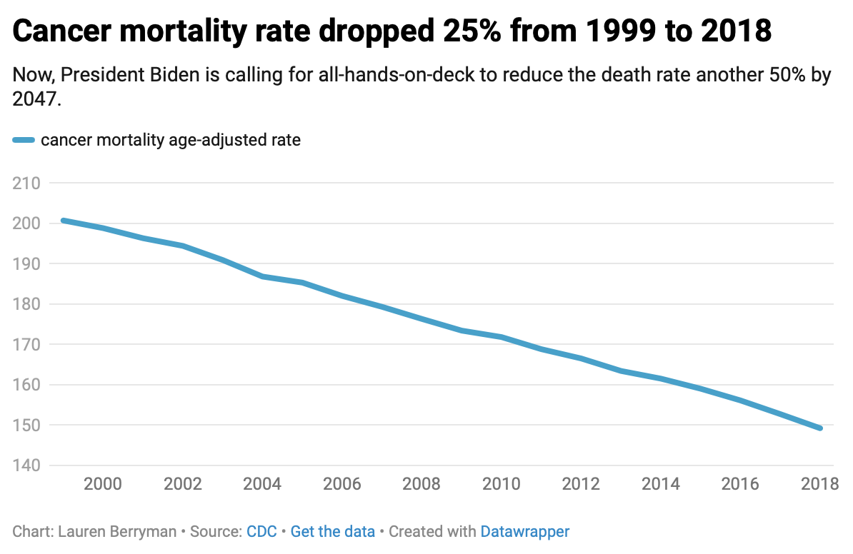

Dr. Adamson, a pediatric oncologist who now works in the private sector of drug development, points to the approval of imatinib in 2001 as the seminal event to increasing the cancer survival rate.

The drug, also called Gleevec, improved outcomes for adults with chronic myelogenous leukemia, a blood cancer. The drug increased the survival rate from [22% to 90%](https://www.cancer.org/cancer/chronic-myeloid-leukemia/detection-diagnosis-staging/survival-rates.html).

He said this was the first of many targeted therapies to develop and a “fundamental change” in how doctors treat cancer. Researchers study the target and the cancer before developing the drug rather than coming up with a treatment and then seeing if it works.

He also said the rise of immuno-oncology, or treatments that use one’s own immune system to fight cancer, has played a significant role.

“What we considered undruggable five years ago, five years from now are probably going to be druggable,” he said.

Still, there are many hurdles when it comes to cancer diagnosis and treatment. Black Americans are disproportionately affected by cancer. Data shows that each year from 1999-2018, these people have faced lower survival rates for breast, prostate and colon cancers — some of the most common.

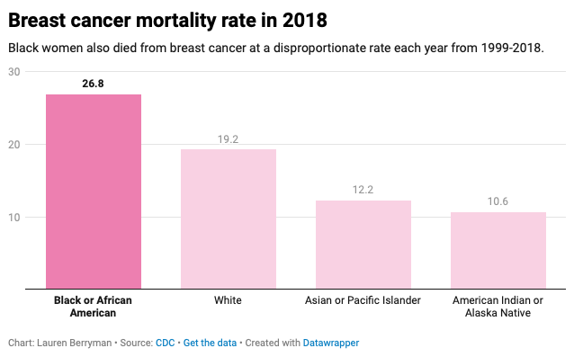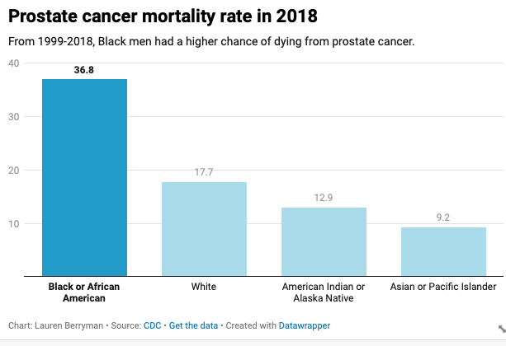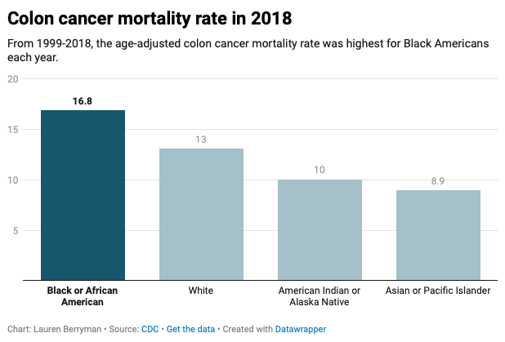

Dr. Erin Linnenbringer, assistant professor at Washington University in St. Louis’s Institute for Public Health, researches the intersection of genetic and social risk factors that contribute to these disparities.

Some people of color have a lack of trust in the medical system because of the history of racism in medicine or because of their own direct experience with discrimination, Linnenbringer said.

Caitlin Donovan, the senior director of public relations at the National Patient Advocate Foundation, also explained that one’s race, income and address impact their access to care.

“People who are white are more likely to get access to clinical trials,” Donovan said. She added that it is important to ensure people of color, women and people living in rural areas have equal access to clinical trials so that they are representative of who would use the drug.

In addition to these challenges, the implications of Covid-19 pose an additional burden on addressing cancer in the country.

During 2020, nearly 10 million Americans missed routine cancer screenings, a [report](https://www.aacr.org/about-the-aacr/newsroom/news-releases/aacr-releases-report-outlining-impact-of-covid-19-pandemic-on-cancer-research-and-patient-care/) released earlier this month by the American Association for Cancer Research found. With early detection being critical for cancer outcome, those who work in the cancer community are worried.

“There's a lot of concern that we're going to start seeing an uptick in both diagnoses and later stages of those diagnoses,” Linnenbringer also said.

“I think we’re going to see an increase in cancer mortality,” Dr. Adamson said.

The pandemic has proved to be not only a health issue but also a political issue. People across the country are divided on vaccine mandates. Donovan at the National Patient Advocate Foundation raised the concern about how that debate could trickle into other aspects of health.

“How many families now aren't getting the HPV vaccine? Are we going to see a spike in cervical cancers among kids who are that generation?” she asked.

While Dr. Adamson is also concerned about the ramifications of the pandemic, he also sees a silver lining.

He thinks mRNA technology, which was used to create the Pfizer and Moderna vaccines in record time, could advance cancer therapeutics.

“I am optimistic. I do think that science is at the right place,” Dr. Adamson said. “As far as how quickly it's moving, it can deliver.”

While the specific details of the re-launched Cancer Moonshot Initiative have not been determined, Fuld Nasso of the National Coalition for Cancer Survivorship hopes to see increased funding for more holistic survivorship care. This kind of care would include patient-tailored care plans to aid the physical, emotional and financial effects of cancer.

Ellis, who has been in remission for three years, knows firsthand that better patient advocacy is crucial. Motivated to support others dealing with cancer, she now works at the [American Cancer Society](https://www.acs.org/content/acs/en.html) to support fundraising efforts that drive cancer research.

“Cancer is not a gift,” Donovan said. “Cancer is a diagnosis that can bring a heavy, physical and emotional burden. But the people I work with who have cancer or are dealing with cancer are incredibly hopeful people.”

**EXTRA**

* Need for RD:
* A dataset
* Four questions you hope to glean answers to from the dataset
* At least one graph
* At least 150 words of your story.
* Need for FINAL draft:
* A text story of **1,000-1,350 words**
* **Two photographs** or images related to your story. You can make them yourself, or get them online. Either way, these photos need to be credited either in the story text or a caption below the photo.
* A cleaned up **dataset**, following the style we've discussed in class of discrete categories and standardized headers that you have found online or obtained from a source, from a reputable, non-partisan organization
* **7 or more facts in your story based on findings from your data set**, looking at the data and sorting/filtering/counting as we've done in class
* **2 graphs** created with datawrapper based on data points in your data set
* A **data diary** detailing in bullet points what steps you took to clean up your data and how you calculated facts and finding in your story (7 or more) based on the data

**CHARTS**

<https://datawrapper.dwcdn.net/KWBSx/3/>

<https://datawrapper.dwcdn.net/CplLu/2/>

<https://datawrapper.dwcdn.net/U2dzj/2/>

<https://datawrapper.dwcdn.net/mlt2g/1/>